**Final Assessment**

**Project:** Building a Simple Online Store Website

**Project Duration:** Two (2) Days

**Time:** 8:30 AM – 5:30 PM

**Assessment Criteria:**

The candidates should demonstrate the following during the assessment period:

* Can create and manipulate database using MySQL
* Can layout and structure web pages using HTML and CSS
* Can apply and use Javascript technology (including jQuery, AJAX, etc)
* Can understand and formulate program design and logic and translate it to codes
* Can connect MySQL database to PHP and can perform CRUD operations

**Web Page Layout**

Below is the provided layout for the online store website. Images and text will be provided to you during the assessment. All links should be working and images should be displayed and not broken.



**Database Design**

**Database Name:** Shopping Cart

**CATEGORY TABLE**

* **catID**
* **catName –** represents the category of product (watch, blouse, shirts, etc)

**PRODUCT TABLE-**  all products of the store are stored in this table. This table has a foreign key **catID** which identifies ID of the category to which a product belongs.

* productID
* productName
* price
* gender – tells on what gender does the product belongs
* catID – foreign key from category table
* image-the path of the image file

**CUSTOMER TABLE –** contains all information about the customers. Customers must be able to sign up first on the website before proceeding to shopping online.

* custID
* custName
* address
* contactNo.

**ORDER** - this table stores information about all orders made by visitors of your store.

* orderID
* orderDate
* custID – represents the customer who is ordering the product
* productID-represents the product to be ordered by the customer
* quantity

**USER ACCOUNT TABLE –** to be used by the ADMINISTRATOR/s that will logged in to the dashboard

* userID
* username
* password

**Shopping Cart Module**

The Shopping Cart module will allow the user to browse and shop online on the shopping store. Your module should be able to do the following

* Display all product from the database (Catalog).
* Product display can be viewed based on category or gender.
* Only registered customer can view this page once they logged in
* Can view products in detail and put quantity once ordered.
* Ordered products can be viewed on the *shopping cart.*
* Once checked out transaction should be saved on the database.



Product Catalog



Detailed View

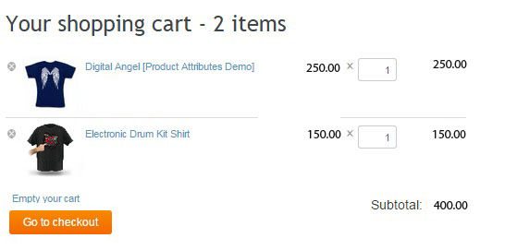

Shopping cart

**The Administrator Page (Dashboard)**

The dashboard will be the page wherein the store administrator can add, edit and delete products. Any product manipulation should also be reflected on the online store website. The dashboard also should display all ordered products from the online store. A login is required before entering the administrator page.